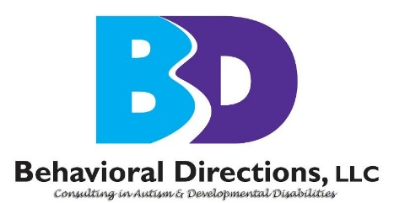
Behavioral Directions, LLC
46090 Lake Center Plaza, Suite 101
Sterling, VA 20165
Office: (703) 855-4032

New Client Referral Form

Client Information
Child’s Name: |  | Date of Birth: |  |  | Sex:
 |  |  |  |  | M / F
Parent /Guardian #1 Name: |  | Parent /Guardian #2 Name:
Home Phone | Work Phone | Home Phone: |  | Work Phone:
Address: |  | Address:
City, State, ZIP: |  | City, State, ZIP:

Referral Information
Who referred you to our services (name of doctor, agency, etc.)?
Reason for seeking services:
Is your child in school? If so, list type of program (non-categorical special education, mainstream, autism classroom, etc.)?
What is the name of your child's school?
Are you seeking a home-based ABA program or more home/school coordination or evaluation of learning needs/placement?
Are there any specific behavioral concerns (tantrums, aggression, self-injury, toileting difficulties, feeding issues, transitions, outings, social skills, etc.)?
If problem behaviors exist, what is being done now to address them?
Do you require any special accommodations to access our services?
Who does your child reside with (e.g., both parents, mother only, father only, etc.)?
Are the child’s parents married to each other? Yes / No
If the child’s parents are unmarried or divorced, we are required to know the legal guardian(s). Please specify joint custody, sole custody, etc. We will require a copy of the legal custody documents to begin services and contact the other parent in joint custody cases for joint participation. Please indicate N/A as needed:

Please return this form by emailing it to us at info@behavioraldirections.com or mailing it to us at Behavioral Directions LLC, 46090 Lake Center Plaza, Suite 101, Sterling, VA 20165. We look forward to being in touch.

